Data Aggregation

🧾 What Is Data Aggregation?
# Source: AI Source: Provided by: [Data Path: Persons Table -> ID Column: 1, Name_En Column: Motasem Essam] -> From: [ChatGPT] on [2/12/2026]
Data aggregation is the process of collecting and combining multiple pieces of data into a single summarized result.
👉 It helps turn raw data into useful insights.

✅ Simple Definition:
# Source: AI Source: Provided by: [Data Path: Persons Table -> ID Column: 1, Name_En Column: Motasem Essam] -> From: [ChatGPT] on [2/12/2026]
Data aggregation is grouping and summarizing data to get meaningful results.

🧠 Real-Life Analogy:
# Source: AI Source: Provided by: [Data Path: Persons Table -> ID Column: 1, Name_En Column: Motasem Essam] -> From: [ChatGPT] on [2/12/2026]
Think of it like a monthly bill summary 🧾:
● You have many small expenses
● At the end → you calculate total spending
👉 Many values → one summary

🔁 How Data Aggregation Works
# Source: AI Source: Provided by: [Data Path: Persons Table -> ID Column: 1, Name_En Column: Motasem Essam] -> From: [ChatGPT] on [2/12/2026]
- 📥 Collect data (multiple records)
- 🧮 Apply operations (sum, count, average, etc.)
- 📊 Combine results
- 📤 Return summarized data

📊 Common Aggregation Operations

🔹 1. Sum (Total)
# Source: AI Source: Provided by: [Data Path: Persons Table -> ID Column: 1, Name_En Column: Motasem Essam] -> From: [ChatGPT] on [2/12/2026]
👉 Add values
Example:
- Total sales

🔹 2. Count
# Source: AI Source: Provided by: [Data Path: Persons Table -> ID Column: 1, Name_En Column: Motasem Essam] -> From: [ChatGPT] on [2/12/2026]
👉 Count number of items
Example:
- Number of users

🔹 3. Average
# Source: AI Source: Provided by: [Data Path: Persons Table -> ID Column: 1, Name_En Column: Motasem Essam] -> From: [ChatGPT] on [2/12/2026]
👉 Calculate mean value
Example:
- Average rating

🔹 4. Min / Max
# Source: AI Source: Provided by: [Data Path: Persons Table -> ID Column: 1, Name_En Column: Motasem Essam] -> From: [ChatGPT] on [2/12/2026]
👉 Find smallest or largest value
Example:
- Highest price
- Lowest score

💻 Simple PHP Example
# Source: AI Source: Provided by: [Data Path: Persons Table -> ID Column: 1, Name_En Column: Motasem Essam] -> From: [ChatGPT] on [2/12/2026]
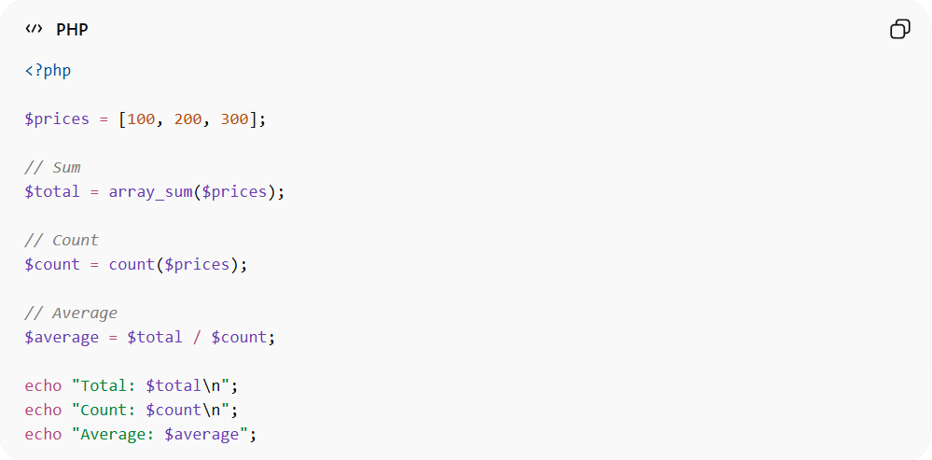
<?php

$prices = [100, 200, 300];

// Sum
$total = array_sum($prices);

// Count
$count = count($prices);

// Average
$average = $total / $count;

echo "Total: $total\n";
echo "Count: $count\n";
echo "Average: $average";
● Combines multiple values
● Produces summarized results

📦 Example (Before vs After)
# Source: AI Source: Provided by: [Data Path: Persons Table -> ID Column: 1, Name_En Column: Motasem Essam] -> From: [ChatGPT] on [2/12/2026]
Before (raw data):
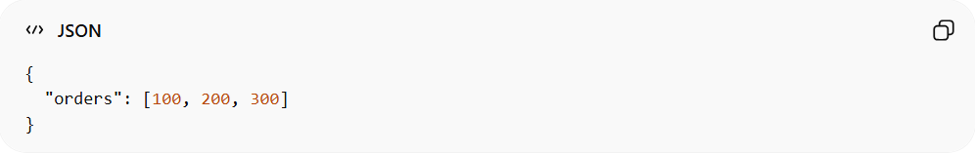
{
"orders": [100, 200, 300]
}
After (aggregated):
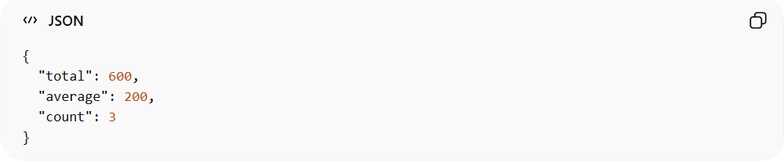
{
"total": 600,
"average": 200,
"count": 3
}
👉 Raw data → meaningful summary

⚠️ Why Data Aggregation Is Important
# Source: AI Source: Provided by: [Data Path: Persons Table -> ID Column: 1, Name_En Column: Motasem Essam] -> From: [ChatGPT] on [2/12/2026]
Without aggregation:
❌ Hard to understand large data
❌ No clear insights
❌ Difficult decision-making
👉 Aggregation simplifies data

🔗 Relation to Other Topics
# Source: AI Source: Provided by: [Data Path: Persons Table -> ID Column: 1, Name_En Column: Motasem Essam] -> From: [ChatGPT] on [2/12/2026]
● Input Handling → collects data
● Transformation → prepares data
● Business Logic → may use aggregation
● Data Aggregation → summarizes data

⚙️ Best Practices
# Source: AI Source: Provided by: [Data Path: Persons Table -> ID Column: 1, Name_En Column: Motasem Essam] -> From: [ChatGPT] on [2/12/2026]
✅ Use aggregation for reports
✅ Avoid unnecessary calculations
✅ Keep data accurate
✅ Use database aggregation when possible

🎯 Key Idea
# Source: AI Source: Provided by: [Data Path: Persons Table -> ID Column: 1, Name_En Column: Motasem Essam] -> From: [ChatGPT] on [2/12/2026]
👉 Aggregation = combine + summarize data
👉 Turns raw data into insights

🎓 Final Mental Model
# Source: AI Source: Provided by: [Data Path: Persons Table -> ID Column: 1, Name_En Column: Motasem Essam] -> From: [ChatGPT] on [2/12/2026]
● Raw data → many values
● Aggregation → one result
👉 Example:
- Many orders → total sales

